

ONLINE RAILWAY

RESERVATION

SYSTEM

TEAM MEMBERS:

**Acknowledgement**

The satisfaction that accompanies the successful completion of this project would be in complete without the mention of the people who made it possible, without whose constant guidance and encouragement would have made efforts go in vain. I consider myself privileged to express gratitude and respect towards all those who guided us through the completion of this project.

I convey thanks to my project guide **PROF.HUSSAIN SYED** of Computer Science and Engineering Department for providing encouragement, constant support and guidance which was of an immense help to complete this project successfully.

Last but not the least, we wish to thank our **parents** for financing our studies in this college as well as for constantly encouraging us to learn engineering. Their personal sacrifice in providing this opportunity to learn engineering is gratefully acknowledged.

ABSTRACT:

Information about the trains available and the cancellation of tickets, number of trains available and other such information are provided.

Stores information about the various transactions related to rail travel.

User can enquire about the PNR status, seat availability and trains.

User friendly interface to administrator and customer.

**Table of Contents**

1. INTRODUCTION

1.1. Purpose

1.2. System Overview

1.3. Problem Statement

1.4. Goal & Vision

1.5. DFD Modelling of Problem

1. REQUIREMENTSSPECIFICATIONS

2.1. User Characteristics

2.2. Hardware Requirements

2.3 Functional requirements

1. DESIGN

3.1. Interface Design

1. CODING
2. TESTING

INTRODUCTION:

OBJECTIVE:

The purpose of this project is to describe the railway reservation system which provide the train timing details, reservation, billing and cancellation on several types of reservation namely.

* Confirm reservation for confirm seat.
* Reservation against cancellation.
* Waiting list reservation.
* Online reservation.
* Tatkal reservation.

The origin of most software systems is in the rear of a client, who either wants to automate the existing manual system or desires a new software system. The software system itself created by the developer. Finally, the end user will use the completed system. Thus, there are three major parties interested in a new system, the client the user, and the developer somehow the requirement s for the system that will satisfy the needs of the client and the concerns of the user must be communicated to the developer. The problem is that the client doesn’t usually design the software, or the software development process and the developer does not understand the client’s problem and the application area. This causes a communication gap between the parties involved in the development of the project.

The basic purpose of the software requirement specification is to bridge this communication gap. SRS is the medium through which the clients and the users’ needs are accurately specified indeed sirs forms the basis of software development.

Another important purpose of developing an srs is helping the clients understanding their own needs. An srs establishes the basis for agreement between the client and the supplier on what the software product will do.

An srs provides a reference for validation of the final product. A high quality srs is a prerequisite to high quality software and it is also reduces the development cost.

**Scope**

The system will be designed to provide an electronic version of the railway passenger reservation system in Indian.

The objectives of this development effort are:

* To provide an avenue for customers to get their tickets in a more convenient way.
* To implement a prototype of a scaled down version of the final system to test the solution and further develop requirements.
* To collect statistics in a more efficient manner for future railway development and construction.
* To increase efficiency of railways.
* The idea of efficient reservation is expected to prove very useful in the daily life of passengers as compared to the conventional system. If it turns out as expected, then it would create a huge impact on the turnaround of passengers towards the railways, increasing their level of trust.

Spiral model

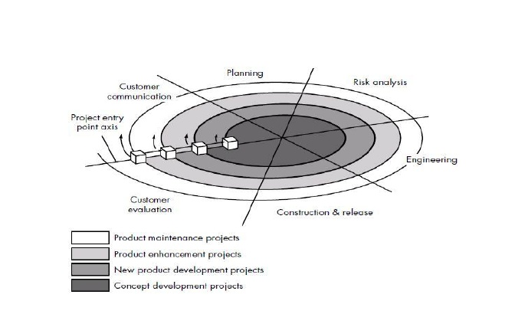

**Spiral development model**

The spiral model is a software development process combining elements of both design and prototyping-in-stages,to combine advantages of top-down and bottom-up concepts. This model of development combines the features of the prototypingmodel and the waterfall model. The spiral model isintended for large, expensive and complicatedprojects.

A spiral model is divided into severalframework activities Typically, there are between three and six taskregions. Fig depicts a spiral model that contains six task regions:

CUSTOMER COMMUNICATION: tasks required to establish effective communication between developer and customer.

PLANNING: tasks required to define resources, timelines, and other project related information.

RISK ANALYSIS: tasks required to assess both technical and management risks

ENGINEERING: tasks required to build one or more representations of the application.

CONSTRUCTION AND RELEASE: tasks required to construct, test, install, and provide user support (e.g., documentation and training)

CUSTOMER EVALUATION: tasks required to obtain customer feedback based of evaluation of the software representation created during the engineering stage and implementation during the installation stage.

System overview

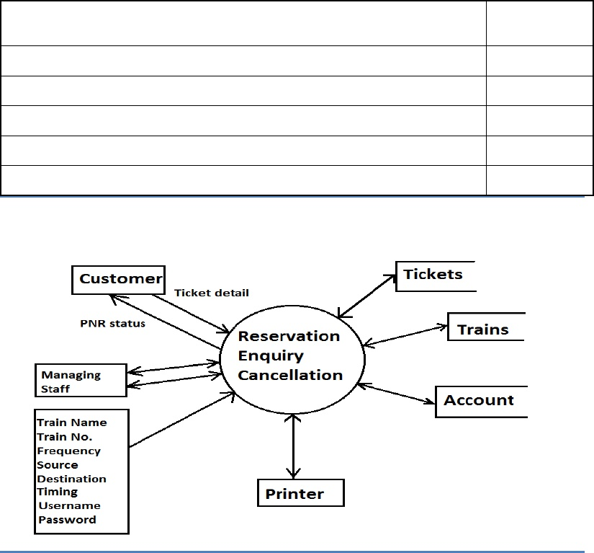

The remainng section of this document provide a general description, including charecterstics of the user of this project the product’s hardware and the functional and data requirements of the project. General description of the project is discussed in the document. It gibes the specific requirements of the product. It gives the external interface requirements and gives detailed description of the functional requirements.

PROBLEM STATEMENT:

The online reservation system is mainly handled by irctc but many of the people are not satisfied to the server at the time of any booking to happen they must re-enter the captcha and continue to overcome this problem we came up with a new code for the railway reservation system.

**DEFNITION OF THE PROJECT:**

This is a project which is used to create and cancellation and to get the reservation details.

**PRODUCT AND ITS FUNCTIONING:**

The product of this project is railway reservation system which is create reservation, cancel reservation, viewing train information, viewing reservation details.

**FUNCTIONS:**

**TRAIN DETAILS:**

Customers may view the train timing at a date their name and number of tickets.

**RESERVATION:**

 After checking the number of seats available the customers reserve the tickets

**CANCELLATION:**

If the customers want to cancel the ticket, then half of the amount paid by the customer will be refunded to him.

**REQUIREMENTS:**

Variety of compartments based on comfort :

• AC first class.

• AC sleeper.

• First class.

• AC three tier.

• AC chair car.

• Sleeper class.

• Ordinary chair car.

**INTERFACES:**

**HARDWARE INTERFACES:**

This project requires the Microsoft windows based system.

**SOFTWARE INTERFACES:**

The project requires dev c++ for the interface.

SYSTEM DESCRIPTION:

GOAL AND VISION

Project is divided into major activities. The activities should be neither small nor too long.

1.communication: it involves meeting with stake holders, and communicate their requirements, information and specific need.

In this project the specified needs are: -

* Databases required (for developing the original software)
* Categories of trains
* Information about the working of the system.

2.planning: with the reference to the information gathered, planning is done to determine how the system will work.

It includes: -

* Planning about booking
* Planning about cancellation
* Planning about enquiry
* Planning about the availability status
* Planning about PNR generation

3. DESIGN: layout of the railway system is made which acts as an interface to the user.

4.TESTING AND CONSTRUCTION: testing is done to check the reliability of the code and the project.

5. DEPLOYMENT: the project is developed at the customers workplace explaining the user about the functionality of the project.

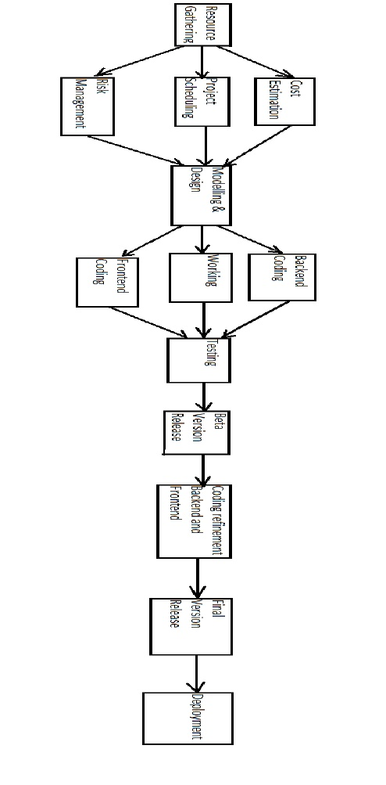FUNCTIONAL MODEL AND DESCRIPTION

DFD MODELLING

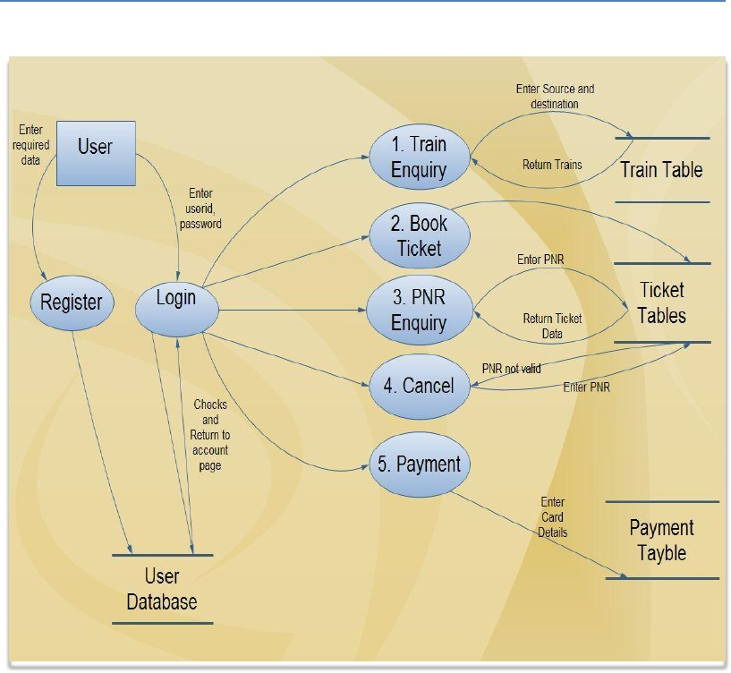

USER LEVEL 1

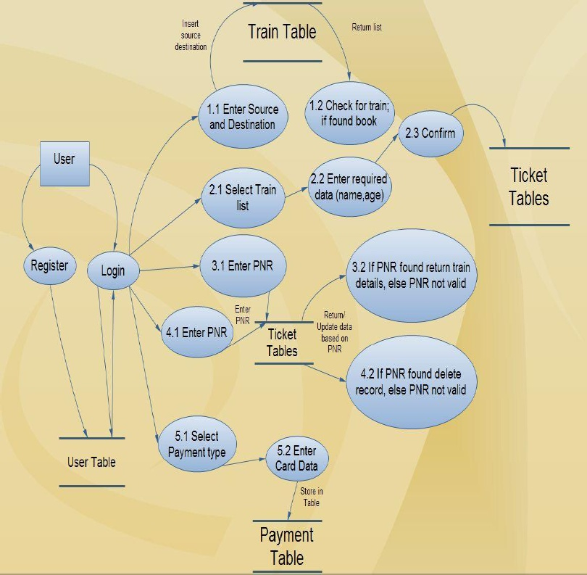

USER LEVEL 2

RESOURSE ALLOCATION

TEAM

MEMBERS

INVOLVED

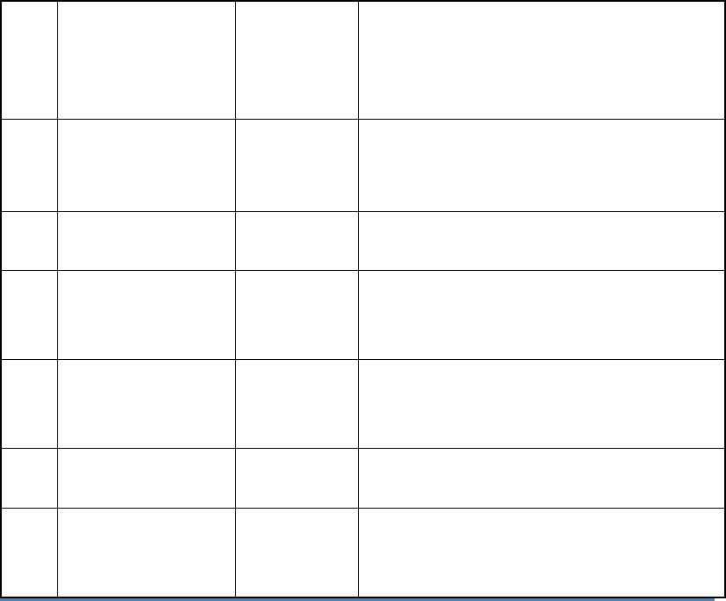

Prepare testing document

Develop source code of the system

Project plan with effort and cost

estimation

Prepare report of the initial

developer meeting, SRSdocumentation

krish

HARSHA

VAMSI

ASHISH

TESTING

IMPLEMENTATION

ANALYSIS AND

DESIGN

RESOURSE

GATHERING

4

3

2

RESPONSIBILITY

PHASE OF SLDC

SR

NO

1

SYSTEM REQUIREMENT SPECIFICATION:

SPECIFIC HARDWARE REQUIREMENTS:

Intel dedicated server family

High speed storage

Dedicated lines for connectivity

Network storage

Printer

Monitor and other general peripherals

FUNCTIONAL REQUIREMENTS:

FUNCTIONAL REQUIREMENTS:

USER SATISFACTION: The system is such that it stands up to the user expectations.

RESPONSE TIME: The response of all the operation is good. This has been made possibly by careful programing.

NON FUNCTIONAL REQUIREMENTS:

SECURITY: The system use in all transactions that include any confedential customer information. The system must automatically log out all customers after a period of inactivity. The system should not leave any cookies on the custumers computer containing the users password. The systems back end serves shall only be accesibel to authenticated management.

AVAILABILITY: The system should be available at all times meaning the user can access it using a web browser, only restricted by the down time of the server on which the system runs. A customer friendly system which is in aceess of people around the world should work 24 hours. In case of a hardware failure or database corruption a replacement page will be shown. Also in case of a hardware failure or database corruption, backups of the database should be retrived from the server and saved by the organiser. Then the service will be restarted. It means 24x7 availability.

MAINTAINABILITY:

A commercial database is used for maintaining the database and the application server takes care of the site. In case of failure, a re-initialization of the project will be done. And also the software design is being done with modularity in mind so that maintainability can be done efficiently.

SUPPORTABILITY:

The code and supporting modules of the system will be well documented and easy to understand. Online user documentation and help system requirements

DATA MODEL AND DESCRIPTION

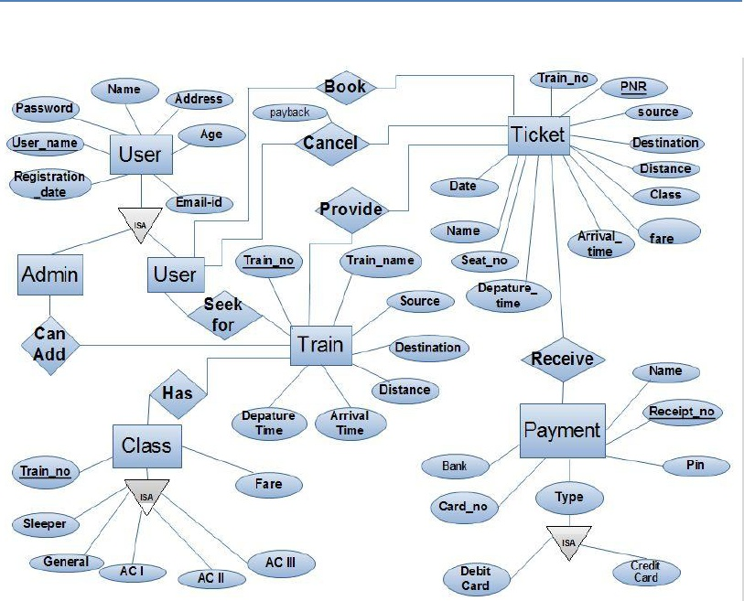

INTERFACE DESIGN:

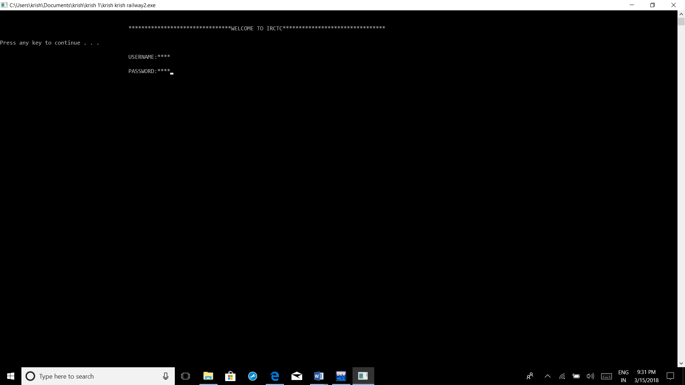

CODING:

#include<iostream>

using namespace std;

#define MAX 10

class passenger

{

private:

char name[30];

int age;

public:

void getDetails(void);

void putDetails(void);

};

void passenger::getDetails(void){

cout<< "\t\t\t\t\tEnter name: " ;

cin>>name;

cout<< "\t\t\t\t\tenter age: ";

cin>>age;

}

void passenger::putDetails(void){

cout<<"\t\t\t\t\tpassenger details:\n";

cout<<"\t\t\t\t\tName:"<<name<<"\n\t\t\t\t\tage:"<<age;

}

int main()

{

passenger std[MAX];

int logout,dd,paymentproceed,mm,yy,n,quota,clas,bank,booktickets,contin,fare,i,age,sex,trainno,loop,service,pnrstatus,cancel;

char fromstation[30];

char tostation[30];

char username[20];

char password[30];

int weekday;

char bankusername[20];

char bankpassword[30];

char a[30];

cout<<"\n\n\t\t\t\t\t********************************WELCOME TO IRCTC********************************\n\n";

system("pause");

cout<<"\n\t\t\t\t\tUSERNAME:";

cin>>username;

cout<<"\n\t\t\t\t\tPASSWORD:";

cin>>password;

system("cls");

cout<<"\t\t\t\t\tyou are successfully logged in......\n";

system("pause");

menu:cout<<"\n\n\t\t\t\t\tMAIN MENU "<<"\n\t\t\t\t\t1.TRAIN ENQUIRY"<<"\n\t\t\t\t\t2.TICKET RESERVATION"<<"\n\t\t\t\t\t3.TICKET CANCELLATION";

cin>>service;

if(service==1)

{

system("cls");

cout<<"\n\n\n\t\t\t\t\t***********************WELCOME TO IRCTC TRAIN ENQUIRY********************************\n\n";

cout<<"\n\t\t\t\t\tFROM STATION:";

cin>>fromstation;

cout<<"\n\t\t\t\t\tTO STATION:";

cin>>tostation;

cout<<"\n\n\t\t\t\t\tenter to which date you want to travel(dd-mm-yy):";

cin>>dd>>mm>>yy;

cout<<"\n\n\t\t\t\t\tthe trains available are\n"<<"\t\t\t\t\t1. T.NO 170543\t"<<fromstation<<" to "<<tostation<<" express\n"<<"\t\t\t\t\t2. T.NO 164893\t"<<fromstation<<" to "<<tostation<<" passenger"<<endl;

cout<<"\n\n\t\t\t\t\ttrain no 1 is available on the days M TH SA\n\n";

cout<<"\n\n\t\t\t\t\ttrain no 2 is available on the days M T W TH F SA SU\n\n";

cout<<"\n\n\t\t\t\t\tplease select the train 1 or 2:";

cin>>trainno;

cout<<"\n\n\t\t\t\t\t01.MONDAY\n\t\t\t\t\t02.TUESDAY\n\t\t\t\t\t03.WEDNESDAY\n\t\t\t\t\t04.THURSDAY\n\t\t\t\t\t05.FRIDAY\n\t\t\t\t\t06.SATURDAY\n\t\t\t\t\t07.SUNDAY";

system("pause");

cout<<"\n\n\t\t\t\t\tpls select the which week day you want to travel:";

cin>>weekday;

if(trainno==1)

{

if(weekday==01||weekday==04||weekday==06)

{

cout<<"\n\n\t\t\t\t\tcertainly will take you to the next step\n";

}

else

{

cout<<"\n\n\t\t\t\t\tenter the correct week day present";

goto notcontinue;

}

}

if(trainno==2)

{

if(weekday==01||weekday==02||weekday==03||weekday==04||weekday==05||weekday==06||weekday==07)

{

cout<<"\n\n\t\t\t\t\tcertainly will take you to the next step\n";

}

else

{

cout<<"\n\n\t\t\t\t\tenter the corrct week day present";

goto notcontinue;

}

}

cout<<"\n\n\t\t\t\t\tenter class do you want to have the seat/s:\n\t\t\t\t\t1.GENERAL\n\t\t\t\t\t2.CHAIR CAR\n\t\t\t\t\t3.SLEEPER CLASS\n\t\t\t\t\t4.FIRST CLASS\n\t\t\t\t\t5.A.C TWO TIRED\n\t\t\t\t\t6.A.C THREE TIRED";

cin>>clas;

switch(clas)

{

case 1:cout<<"\n\t\t\t\t\tthe general class has 120 seats available\t"<<"the fare is 500 rupees"<<endl;

break;

case 2:cout<<"\n\t\t\t\t\tthe chaircar class has 30 seats available\t"<<"the fare is 300 rupees"<<endl;

break;

case 3:cout<<"\n\t\t\t\t\tthe sleeper class has 63 seats available\t"<<"the fare is 800 rupees"<<endl;

break;

case 4:cout<<"\n\t\t\t\t\tthe first class has 10 seats available\t"<<"the fare is 5000 rupees"<<endl;

break;

case 5:cout<<"\n\t\t\t\t\tthe A.C two tire has a waiting list of 33\t"<<"the fare is 3000 rupees"<<endl;

break;

case 6:cout<<"\nthe A.C three tire has a waiting list of 2\t"<<"the fare is 1500 rupees"<<endl;

break;

}

cout<<"\n\n\t\t\t\t\tto log out your account enter 1";

cin>>logout;

if(logout==1)

{

goto notcontinue;

}

else

{

system("cls");

goto menu;

}

}

if(service==2)

{

system("cls");

cout<<"\n\n\n\t\t\t\t\t*******************WELCOME TO IRCTC TICKET RESERVATION*******************\n\n";

cout<<"\n\t\t\t\t\tenter from station:";

cin>>fromstation;

cout<<"\n\t\t\t\t\tenter to station:";

cin>>tostation;

cout<<"\n\n\t\t\t\t\tenter to which date you want to travel(dd-mm-yy):";

cin>>dd>>mm>>yy;

cout<<"\n\n\t\t\t\t\tthe trains availabla are\n"<<"\t\t\t\t\t1. T.NO 170543\t"<<fromstation<<" to "<<tostation<<" express\n"<<"\t\t\t\t\t2. T.NO 164893\t"<<fromstation<<" to "<<tostation<<" passenger"<<endl;;

cout<<"\n\n\t\t\t\t\ttrain no 1 is available on the days M TH SA\n\n";

cout<<"\n\n\t\t\t\t\ttrain no 2 is available on the days M T W TH F SA SU\n\n";

cout<<"\n\n\t\t\t\t\tplease select the train 1 or 2:";

cin>>trainno;

cout<<"\n\n\t\t\t\t\t01.MONDAY\n\t\t\t\t\t02.TUESDAY\n\t\t\t\t\t03.WEDNESDAY\n\t\t\t\t\t04.THURSDAY\n\t\t\t\t\t05.FRIDAY\n\t\t\t\t\t06.SATURDAY\n\t\t\t\t\t07.SUNDAY";

cout<<"\n\n\t\t\t\t\tpls select the which week day you want to travel:";

cin>>weekday;

if(trainno==1)

{

if(weekday==01||weekday==04||weekday==06)

{

cout<<"\n\n\t\t\t\t\tcertainly will take you to the next step\n";

}

else

{

cout<<"\n\n\t\t\t\t\tenter the correct week day present";

goto notcontinue;

}

}

if(trainno==2)

{

if(weekday==01||weekday==02||weekday==03||weekday==04||weekday==05||weekday==06||weekday==07)

{

cout<<"\n\n\t\t\t\t\tcertainly will take you to the next step\n";

}

else

{

cout<<"\n\n\t\t\t\t\tenter the corrct week day present";

goto notcontinue;

}

}

cout<<"\n\n\t\t\t\t\twhich quota do u want:\n\t\t\t\t\t1.GENERAL QUOTA\n\t\t\t\t\t2.LADIES QUOTA\n\t\t\t\t\t3.SENIORCITIZEN QUOTA\n\t\t\t\t\t4.PHYSICALLY HANDICAPED\n\t\t\t\t\t5.TATKAL\n\t\t\t\t\t6.CURRENT RESERVATION";

cin>>quota;

switch(quota)

{

case 1:cout<<"\n\t\t\t\t\tyou have selected general quota..\n";

break;

case 2:cout<<"\n\t\t\t\t\tyou have selected ladies quota..\n";

break;

case 3:cout<<"\n\t\t\t\t\tyou have selected seniorcitizen quota..\n";

break;

case 4:cout<<"\n\t\t\t\t\tyou have selected physically handicaped quota..\n";

break;

case 5:cout<<"\n\t\t\t\t\tyou have selected tatkal quota..\n";

break;

case 6:cout<<"\n\t\t\t\t\tyou have selected current reservation..\n";

break;

default:cout<<"\n\t\t\t\t\tenter the correct quota...\n";

}

cout<<"\n\n\t\t\t\t\tIn which class do you want to have the seat/s:\n\t\t\t\t\t1.GENERAL\n\t\t\t\t\t2.CHAIR CAR\n\t\t\t\t\t3.SLEEPER CLASS\n\t\t\t\t\t4.FIRST CLASS\n\t\t\t\t\t5.A.C TWO TIRED\n\t\t\t\t\t6.A.C THREE TIRED";

cin>>clas;

switch(clas)

{

case 1:cout<<"\n\t\t\t\t\tthe general class has 120 seats available\n"<<"\t\t\t\t\tthe fare is 500 rupees"<<endl;

break;

case 2:cout<<"\n\t\t\t\t\tthe chaircar class has 30 seats available\n"<<"\t\t\t\t\tthe fare is 300 rupees"<<endl;

break;

case 3:cout<<"\n\t\t\t\t\tthe sleeper class has 63 seats available\n"<<"\t\t\t\t\tthe fare is 800 rupees"<<endl;

break;

case 4:cout<<"\n\t\t\t\t\tthe first class has 10 seats available\n"<<"\t\t\t\t\tthe fare is 5000 rupees"<<endl;

break;

case 5:cout<<"\n\t\t\t\t\tthe A.C two tire has a waiting list of 33\n"<<"\t\t\t\t\tthe fare is 3000 rupees"<<endl;

break;

case 6:cout<<"\n\t\t\t\t\tthe A.C three tire has a waiting list of 2\n"<<"\t\t\t\t\tthe fare is 1500 rupees"<<endl;

break;

default:cout<<"\n\t\t\t\t\tenter the correct class do u want";

}

cout<<"\n\n\t\t\t\t\tdo you want to continue for booking (yes=1,no=0):";

cin>>contin;

if(contin==1)

goto forcontinue;

else

goto notcontinue;

forcontinue: cout <<"\n\n\t\t\t\t\tEnter total number of passengers: ";

cin >> n;

for(loop=0;loop< n; loop++){

cout << "\n\t\t\t\t\tEnter details of passengers " << loop+1 << ":\n";

std[loop].getDetails();

}

cout << endl;

cout<<"\n\n\t\t\t\t\tdo you want to book the tickets (1=yes,0=no):";

cin>>booktickets;

if(booktickets=1)

{

bank:cout<<"\n\t\t\t\t\tyou are in the netbanking option..\n";

cout<<"\n\t\t\t\t\tplease select the bank for the payment:\n";

cout<<"\t\t\t\t\t1.STATE BANK OF INDIA\n";

cout<<"\t\t\t\t\t2.INDIAN BANK\n";

cout<<"\t\t\t\t\t3.SYNDICATE BANK\n";

cout<<"\t\t\t\t\t4.BANK OF BARODA\n";

cout<<"\t\t\t\t\t5.AXIS BANK\n";

cout<<"\t\t\t\t\t6.KARUR VYSYA BANK\n";

cout<<"\t\t\t\t\t7.ANDHRA BANK";

cin>>bank;

switch(bank)

{

case 1: system("cls");

cout<<"\n\t\t\t\t\t********************WELCOME TO STATE BANK OF INDIA***************************\n";

break;

case 2:system("cls");

cout<<"\n\t\t\t\t\t********************WELCOME TO INDIAN BANK*******************************\n";

break;

case 3:

system("cls");

cout<<"\n\t\t\t\t\t********************WELCOME TO SYNDICATE BANK****************************\n";

break;

case 4:

system("cls");

cout<<"\n\t\t\t\t\t********************WELCOME TO BANK OF BARODA****************************\n";

break;

case 5:

system("cls");

cout<<"\n\t\t\t\t\t********************WELCOME TO AXIS BANK***************************\n";

break;

case 6:

system("cls");

cout<<"\n\t\t\t\t\t********************WELCOME TO KARUR VYSYA BANK*********************\n";

break;

case 7:

system("cls");

cout<<"\n\t\t\t\t\t********************welcome to the andhra bank****************************\n";

break;

default:cout<<"\n\n\t\t\t\t\tenter correct bank no...";

goto bank;

}

cout<<"\t\t\t\t\tusername:";

cin>>bankusername;

cout<<"\t\t\t\t\tpassword:";

cin>>bankpassword;

cout<<"\t\t\t\t\tdo you want to proceed for the payment(1=yes,0=no):";

cin>>paymentproceed;

if(paymentproceed=1)

{

goto next;

}

else

{

goto notcontinue;

}

}

else

{

goto notcontinue;

}

next:cout<<"\n\t\t\t\t\tthe tickets are booked for the given information \n";

cout<<"\n\t\t\t\t\tfrom station:"<<fromstation<<endl;

cout<<"\n\t\t\t\t\tto station:"<<tostation<<endl;

cout<<"\n\t\t\t\t\tpnr number 6745839251";

for(loop=0;loop< n; loop++)

{

cout<< (loop+1) << ":\n";

std[loop].putDetails();

}

if(quota==1)

{

cout<<"\n\t\t\t\t\tquota:general\n";

}

else if(quota==2)

{

cout<<"\t\t\t\t\tquota:ladies\n";

}

else if(quota==3)

{

cout<<"\t\t\t\t\tquota:seniorcitizen\n";

}

else if(quota==4)

{

cout<<"\t\t\t\t\tquota:physically handicaped\n";

}

else if(quota==5)

{

cout<<"\t\t\t\t\tquota:tatkal\n";

}

else

{

cout<<"\t\t\t\t\tqouta:current reservation\n";

}

if(clas==1)

{

cout<<"\n\t\t\t\t\tclass:general"<<endl;

}

else if(clas==2)

{

cout<<"\n\t\t\t\t\tclass:chair car"<<endl;

}

else if(clas==3)

{

cout<<"\n\t\t\t\t\tclass:sleeper class"<<endl;

}

else if(clas==4)

{

cout<<"\n\t\t\t\t\tclass:first class"<<endl;

}

else if(clas==5)

{

cout<<"\n\t\t\t\t\tclass:A.C two tire"<<endl;

}

else

{

cout<<"\n\t\t\t\t\tclass:A.C three tire"<<endl;

}

cout<<"\t\t\t\t\tseats:"<<n<<endl;

if(clas==1)

{

fare=n*500;

cout<<"\n\t\t\t\t\ttotal fare:"<<fare<<endl;

}

else if(clas==2)

{

fare=n*300;

cout<<"\n\t\t\t\t\ttotal fare:"<<fare<<endl;

}

else if(clas==3)

{

fare=n*800;

cout<<"\n\t\t\t\t\ttotal fare:"<<fare<<endl;

}

else if(clas==4)

{

fare=n*5000;

cout<<"\n\t\t\t\t\ttotal fare:"<<fare<<endl;

}

else if(clas==5)

{

fare=n*3000;

cout<<"\n\t\t\t\t\ttotal fare:"<<fare<<endl;

}

else

{

fare=n*1500;

cout<<"\n\t\t\t\t\ttotal fare:"<<fare<<endl;

}

cout<<"\n\n\t\t\t\t\tto log out your account enter 1";

cin>>logout;

if(logout==1)

{

goto notcontinue;

}

else

{

system("cls");

goto menu;

}

}

if(service==3)

{

system("cls");

cout<<"\n\n\t\t\t\t\t***************************WELCOME TO IRCTC TICKET CANCELLATION*****************************";

cout<<"\n\t\t\t\t\tenter from station:";

cin>>fromstation;

cout<<"\n\t\t\t\t\tenter to station:";

cin>>tostation;

pnr:cout<<"\n\t\t\t\t\tenter the pnr number";

cin>>pnrstatus;

if(pnrstatus!=1234567890)

{

cout<<"\t\t\t\t\tenter correct pnr number...";

goto menu;

}

cout<<"\n\t\t\t\t\tthe given pnr number is the ticket from "<<fromstation<<" to "<<tostation<<endl;

cout<<"\n\t\t\t\t\twould you like to cancel the ticket(1=yes,0=no):";

cin>>cancel;

if(cancel=1)

{

goto cancelticket;

}

else

{

goto menu;

}

cancelticket:cout<<"\n\t\t\t\t\tthe ticket has been cancelled of the pnr number"<<pnrstatus<<endl;

cout<<"\n\t\t\t\t\tto log out your account enter 1";

cin>>logout;

if(logout=0)

{

goto menu;

}

else

{

cout<<"\n\t\t\t\t\tyou are logged out....";

goto notcontinue;

}

}

notcontinue:cout<<"\n\t\t\t\t\tyou are out of the page...."<<"\n visit again...!";

cout<<"\t\t\t\t\tyou are logged out\n";

cout<<"\n\t\t\t\t\tthank you for visiting";

return 0;

}

TESTING:

**Unit Testing:** Unit testing is a software development process in which the smallest testable parts of an application, called units, are individually and independently scrutinized for proper operation. Unit testing is often automated but it can also be done manually. A unit test is an automated piece of code that invokes a ***unit of work*** in the system ***and then checks a single assumption aboutthe behavior of that unit of work***.

In this application , a manually written unit test script method is used for testing function those perform unit amount of work and provides functionality.

CONCLUSION:

The proposed system is error free, stable and capable of handling load at the server even in the peak hours without losing stability or giving a down time.

The software provides security to the user, administrator and the server.

As for the user, the task of booking, cancelling a ticket or making an enquity is made much easier and hassle free